**Problem Statement**:

Create a solution for food recognition and segmentation that lets you upload a photo of several food items and have it correctly identified each one.

**Data Collection**:

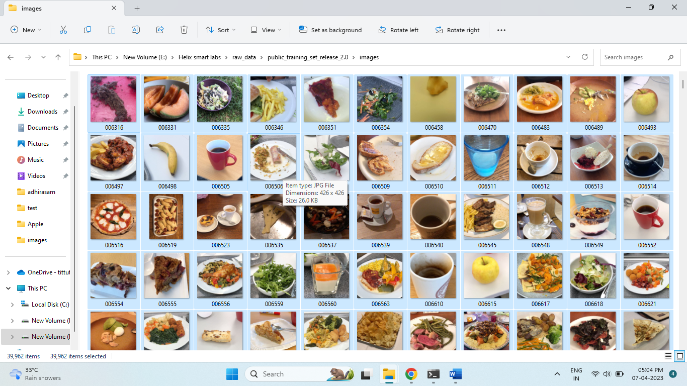

Collected image data set containing images of food items from English menu almost 39.9k images were extracted.

Reference: <https://www.kaggle.com/datasets/sainikhileshreddy/food-recognition-2022>

Since Indian food items were missing from the dataset I downloaded more image data set containing 80 different Indian food items.

Reference: https://www.kaggle.com/datasets/iamsouravbanerjee/indian-food-images-dataset

**Data Pre-processing:**

The first dataset was having almost 40k images without any labelling. So I made use of the Jason file attached to the file which was use to sort the data into different food categories and from the first data set I was able to extract almost 574 food categories and from the second dataset 80 pre-defined classes were there.

The json file was converted into a dataset and with the help of this data the raw images were sorted into different classes

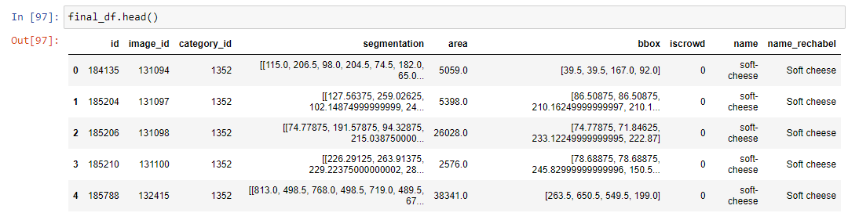

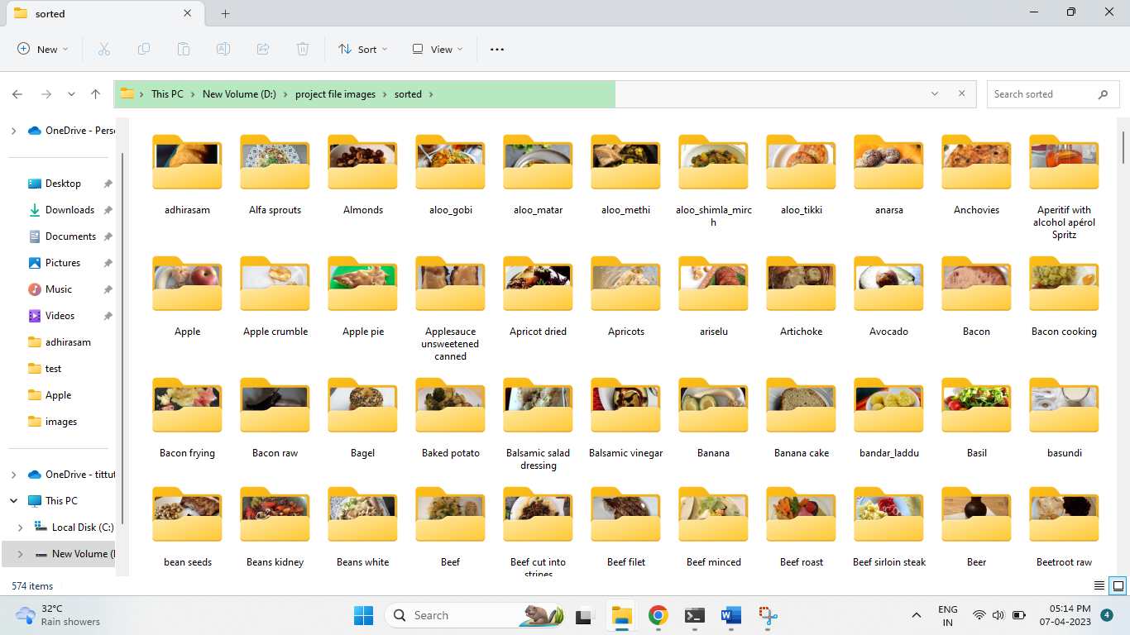

The classes after sorting.

Each classes contain a minimum of 50 images. 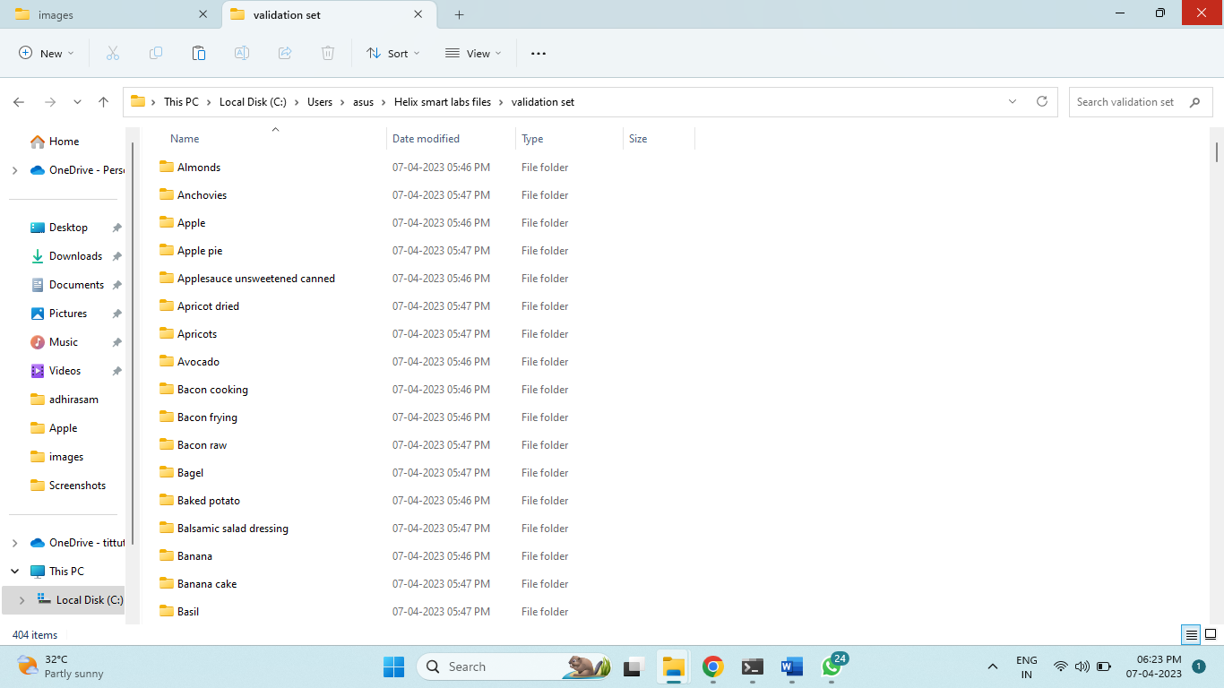

Created validation set containing almost 400 classes.

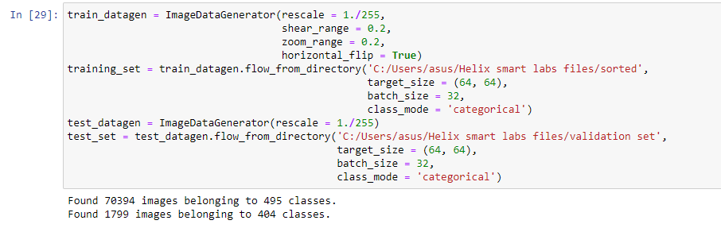

**Defining bounding boxes:**

Custom bounding boxes were defined using the application called Labelimg as part of data pre-processing.

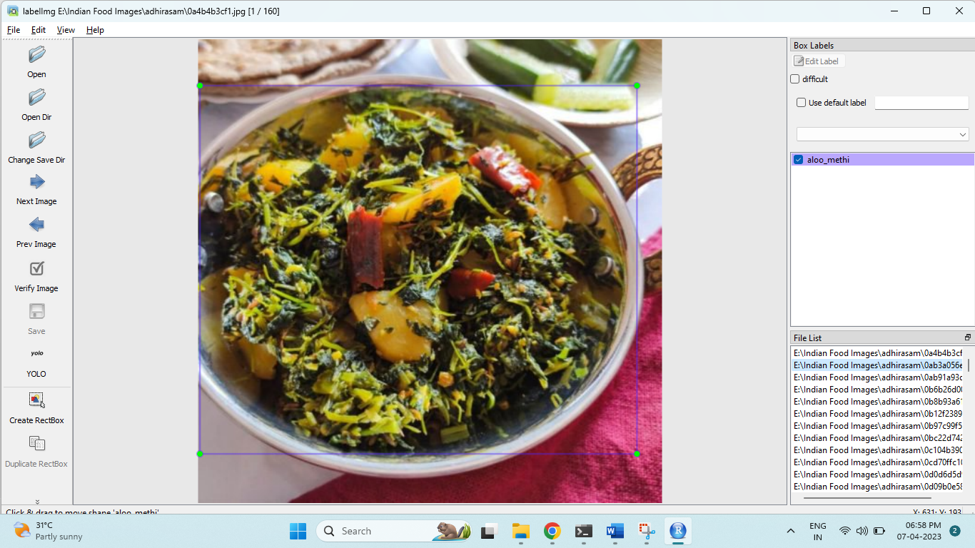

**Model Building :**

Tried building object recognition model using yolo v5 model and we successful in getting object recognition. Tried building Resnet model but due to issues with local machine and limited gpu resource in colab I have to go for yolo v5 model.

**Output of Object Detection:**

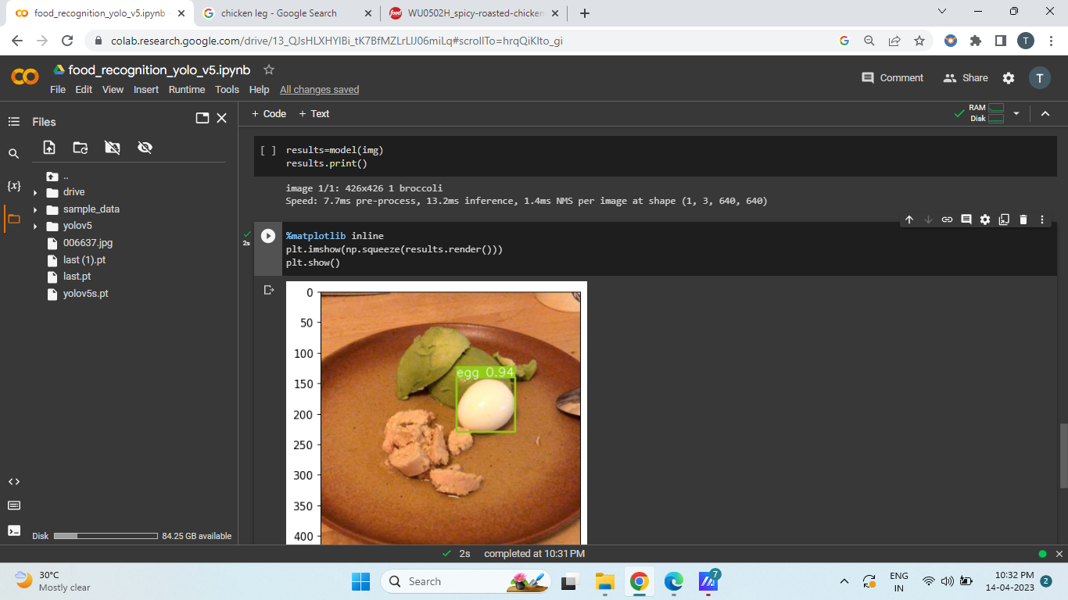 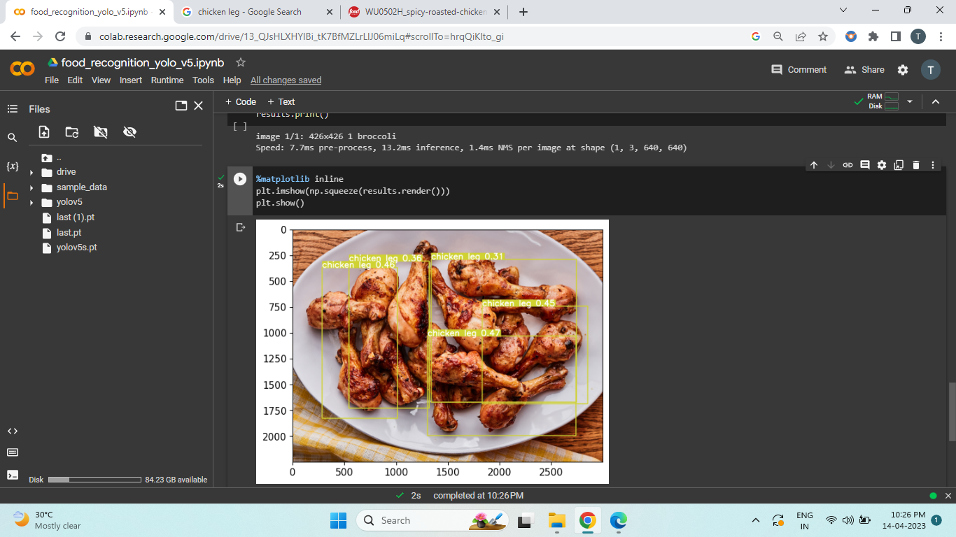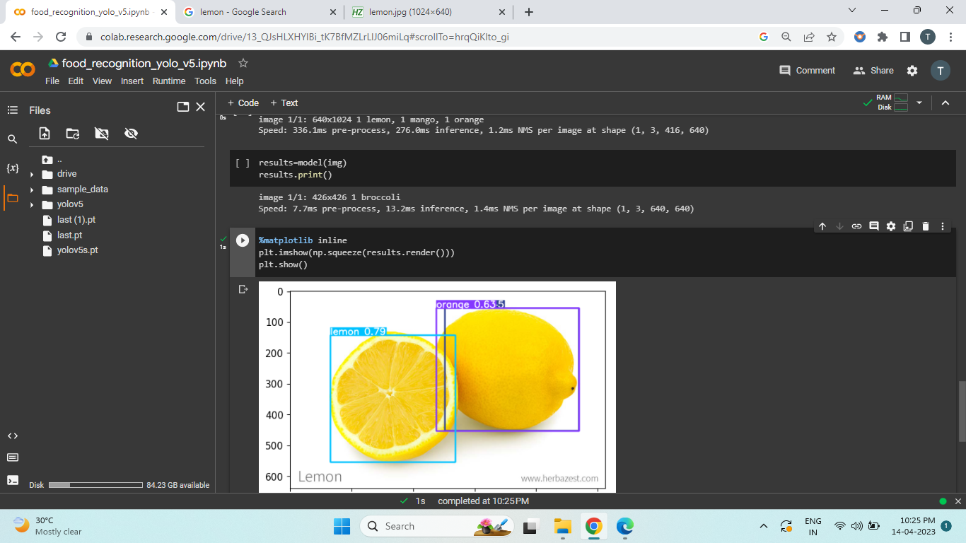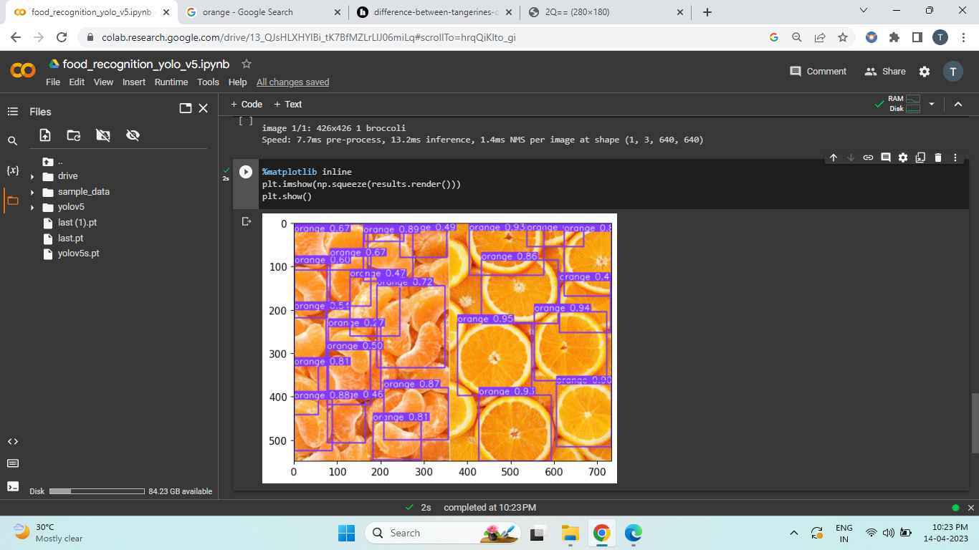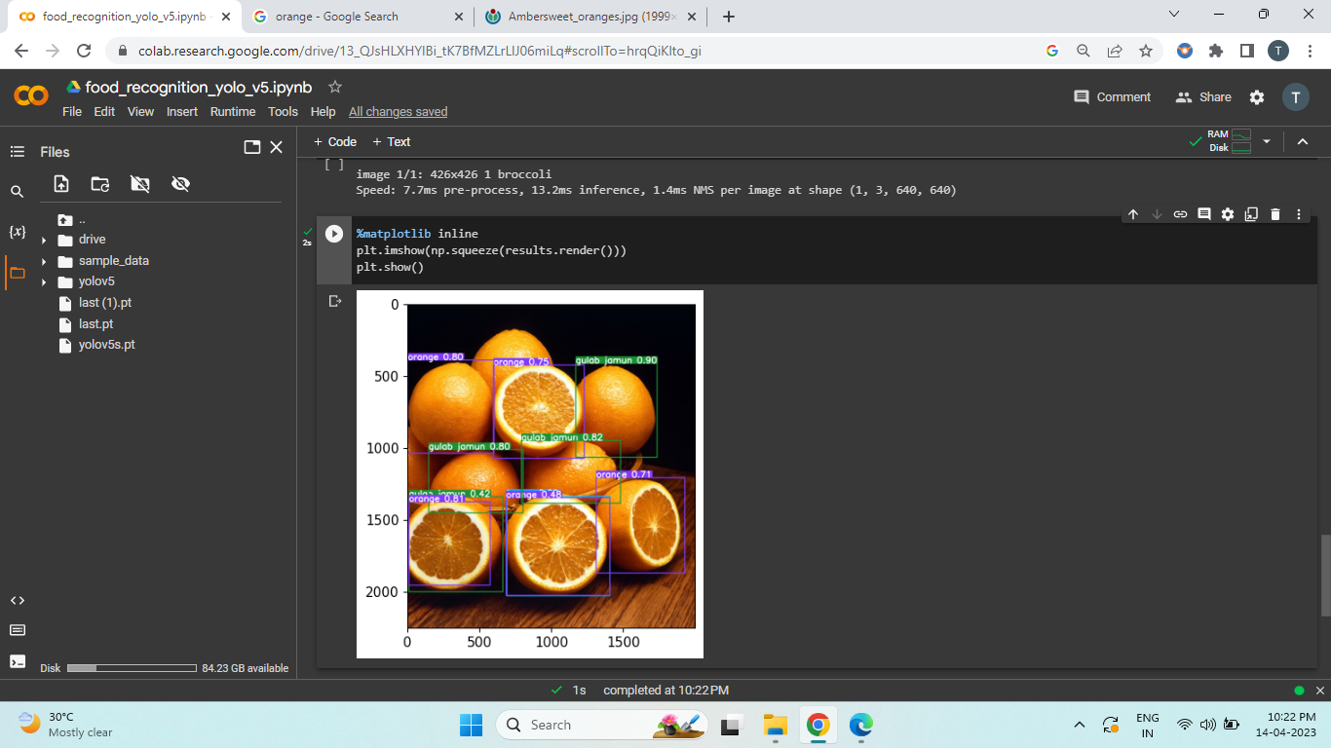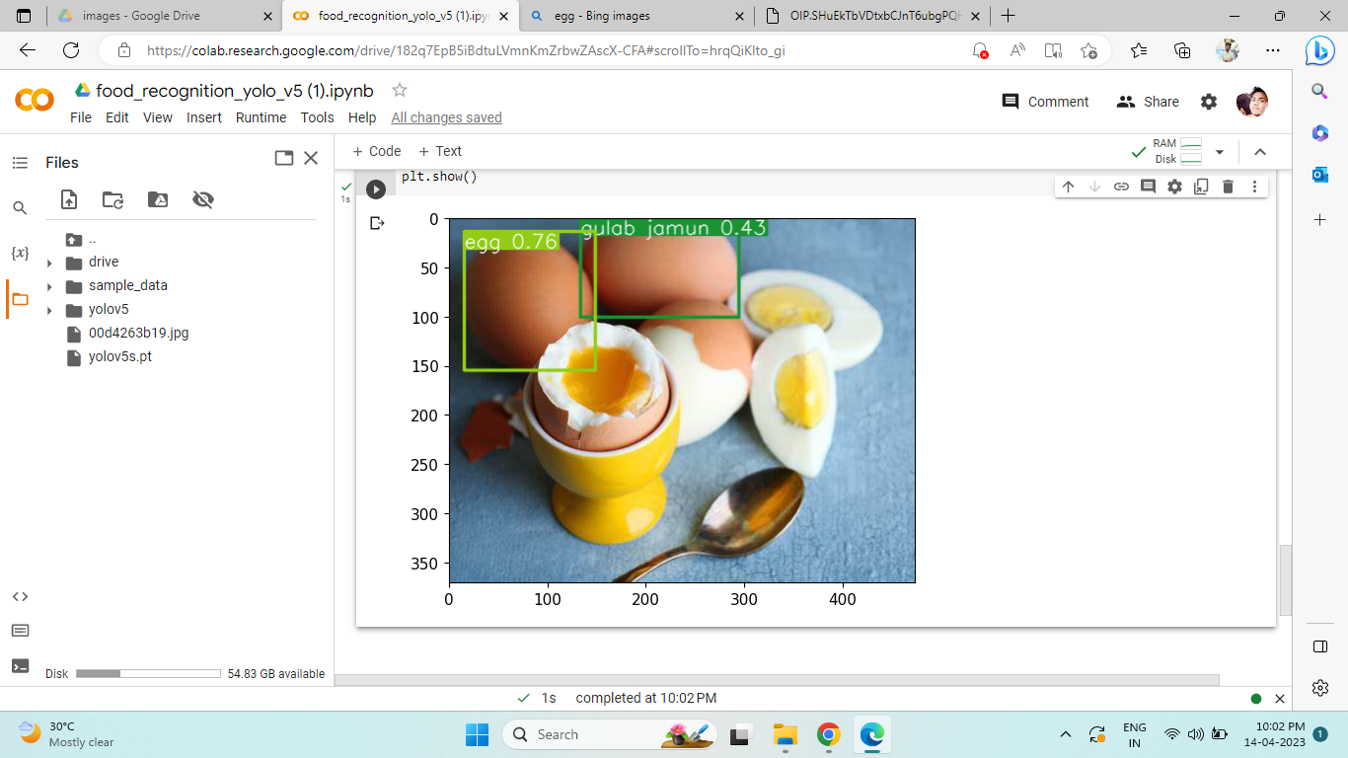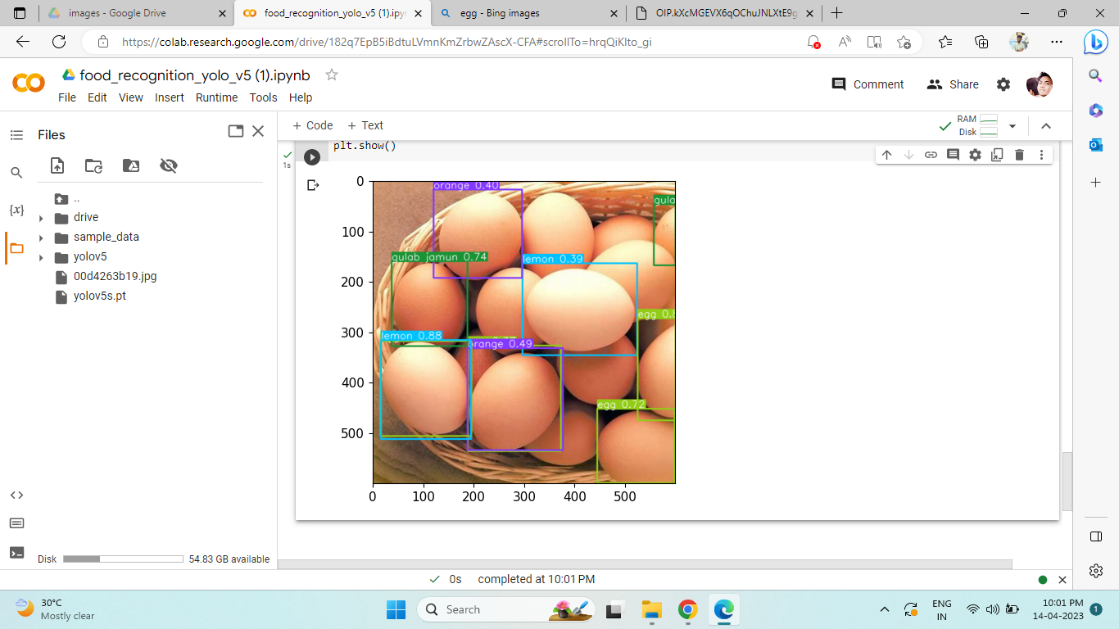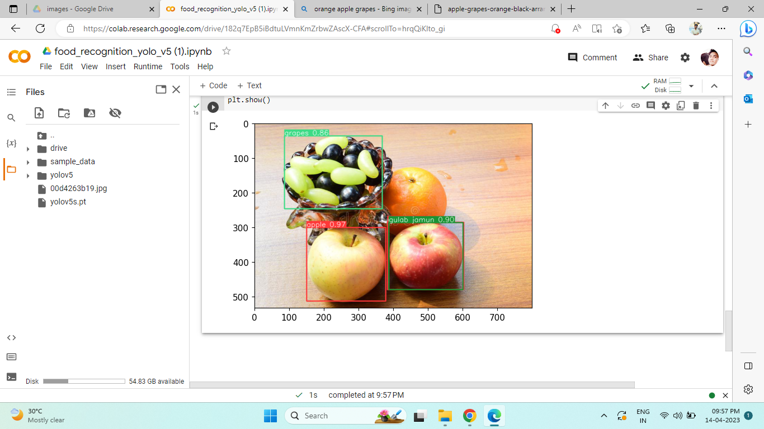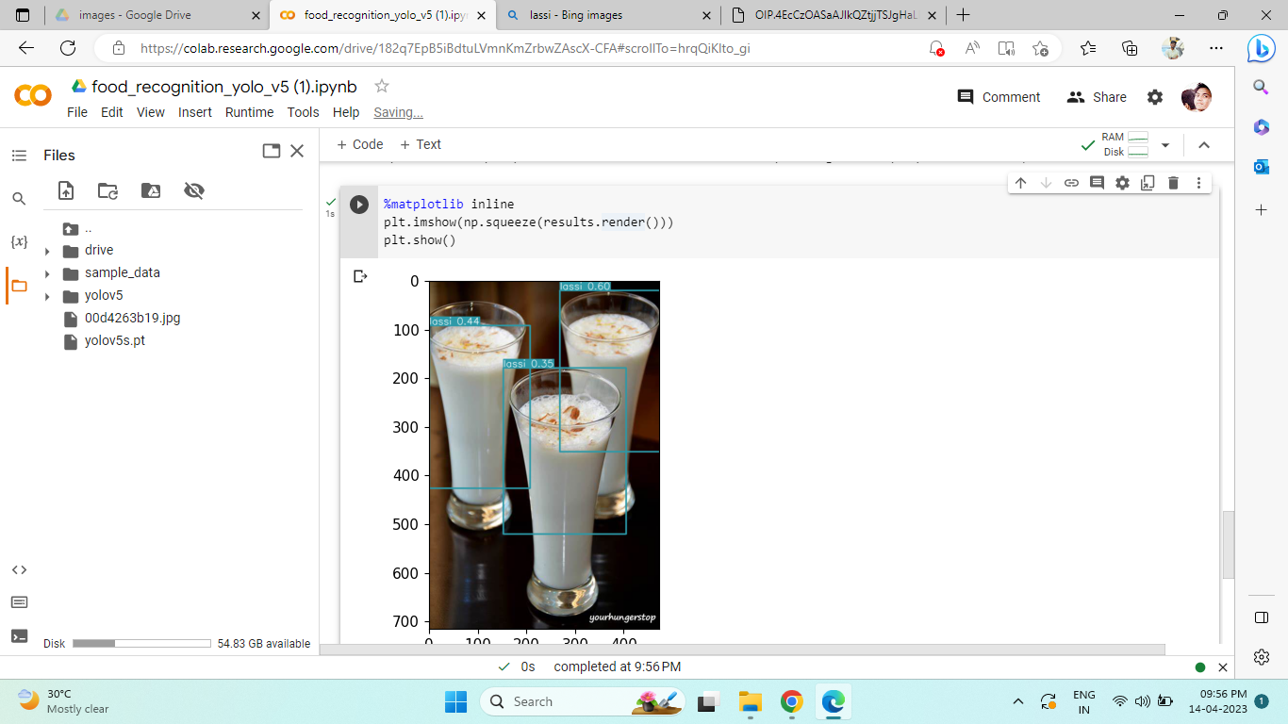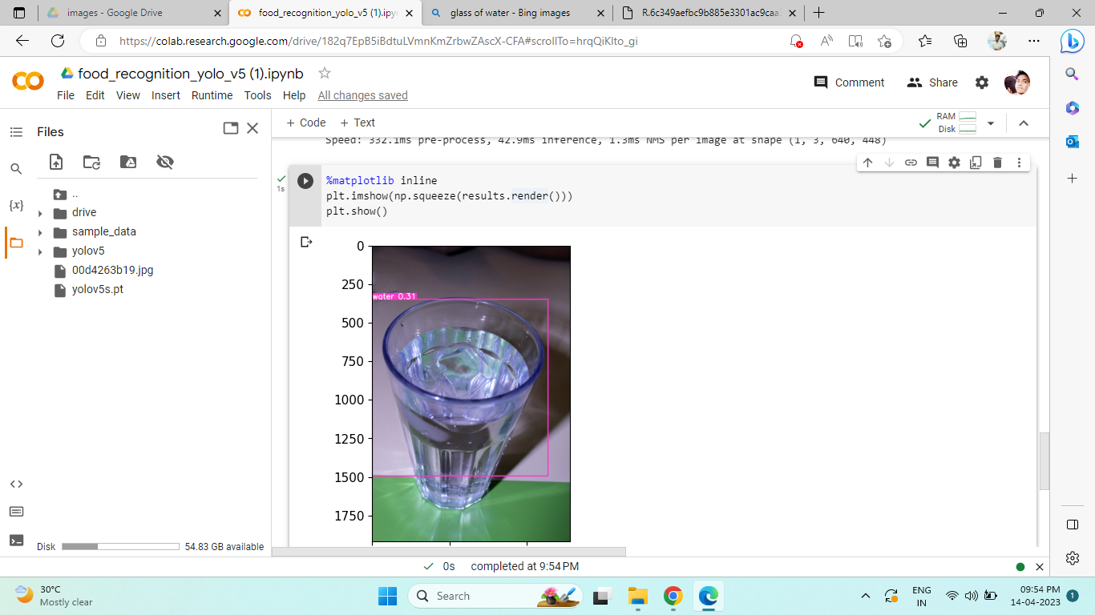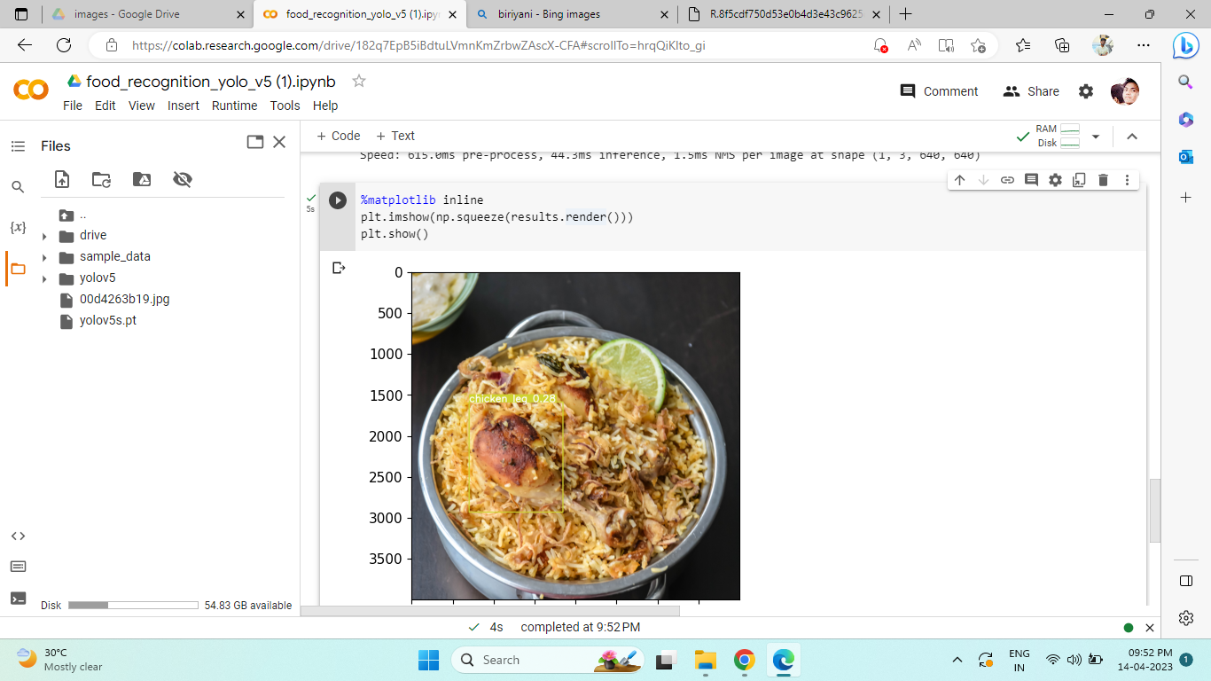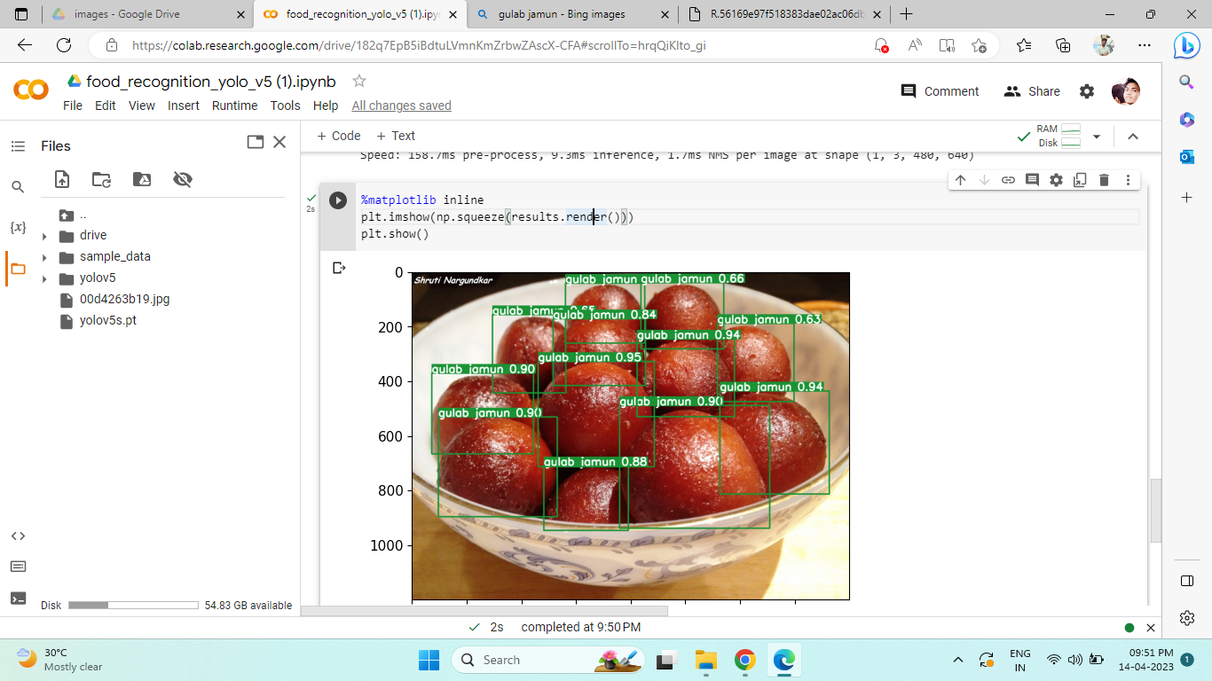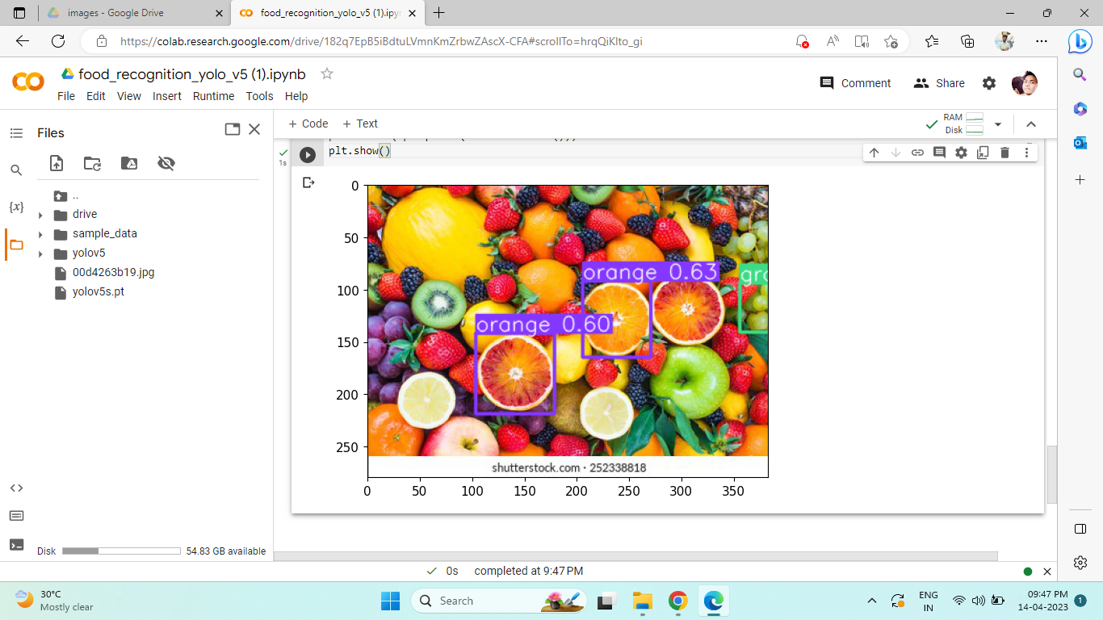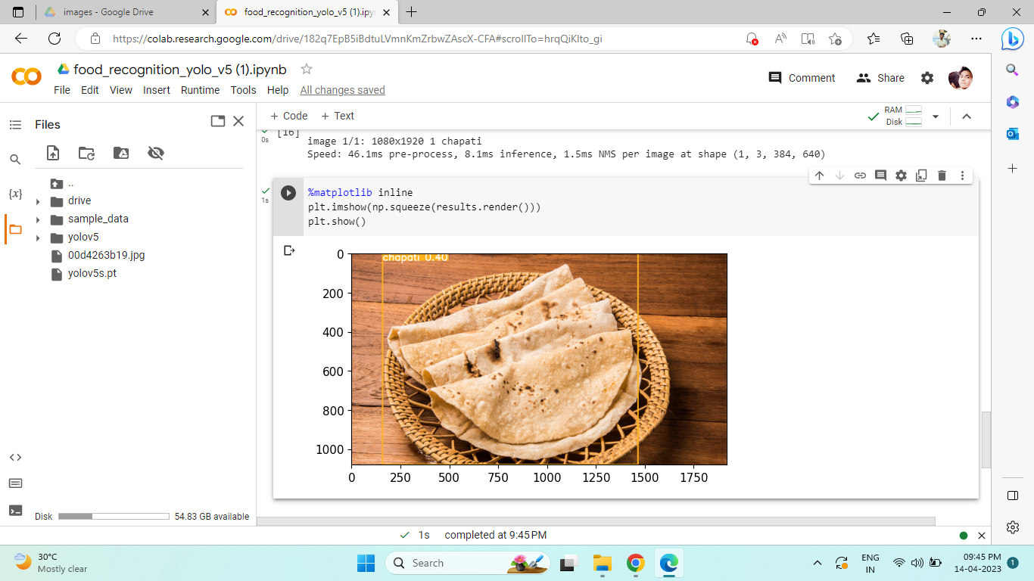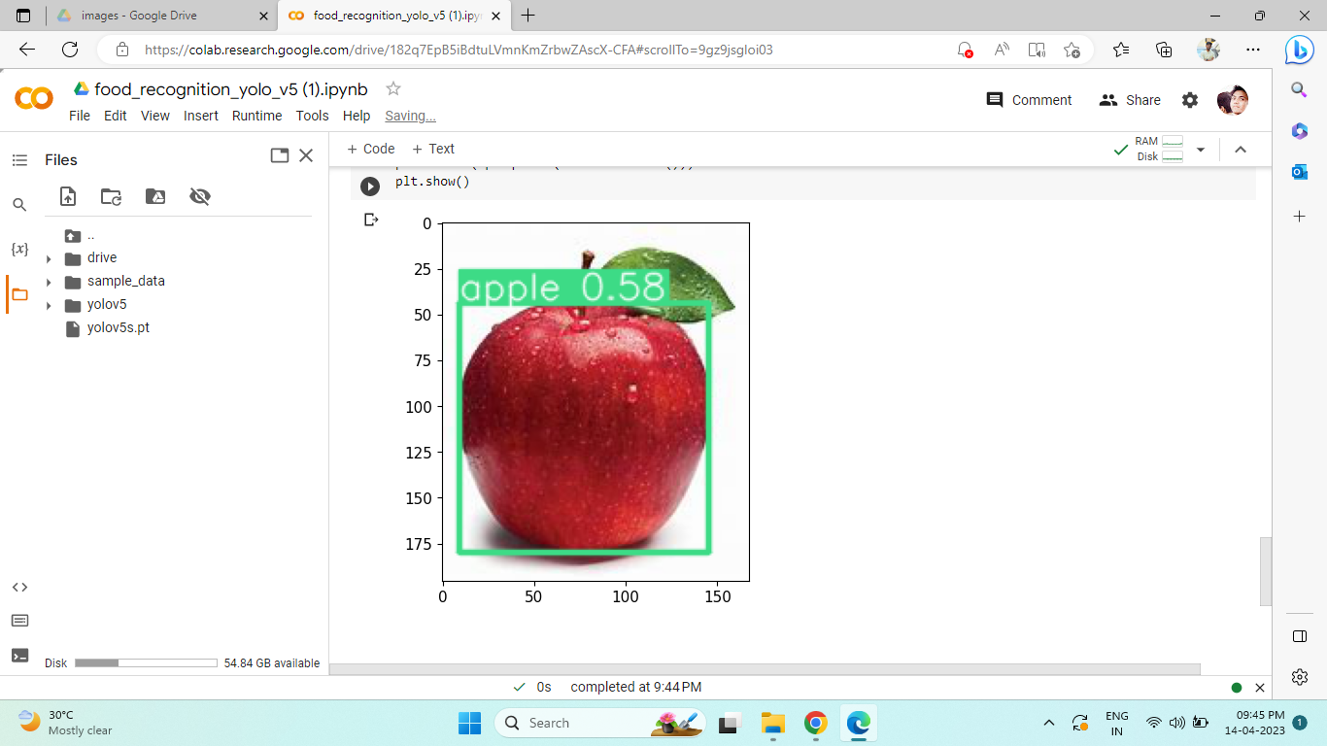

**Classification Model**

Implemented Code to build a classification model where 43 classes of food items were selected into the data and tried building different classification model like Resnet15,Resnet 15v2,Inception V3,etc..

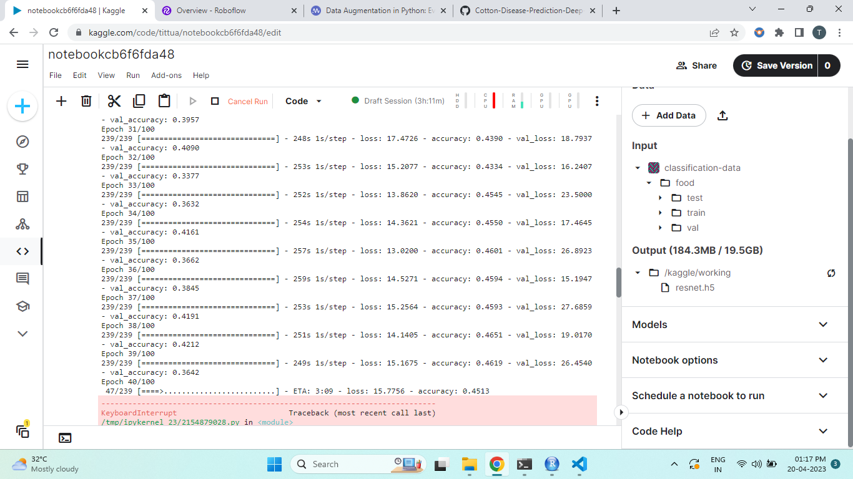

**Resnet 15** -was giving low accuracy after 40 epochs the accuracy was converging to 46%. And validation accuracy was close to 36%.

**Inception V3**

So I tried Inception V3 model and I was getting testing accuracy close to 90% and validation accuracy close to 70%.

**Resnet 15 v2**

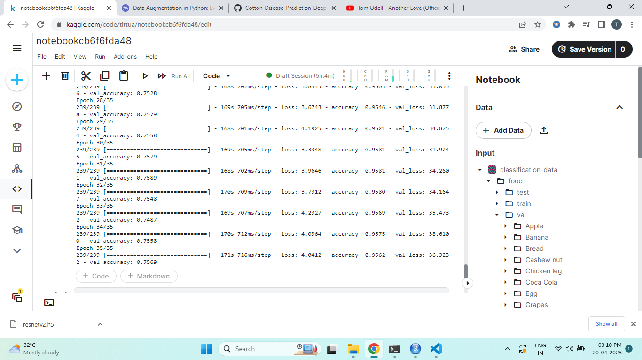

This model was giving the best results so far with training accuracy close to 96% and validation accuracy close to 75%.

**Segmentation Model**

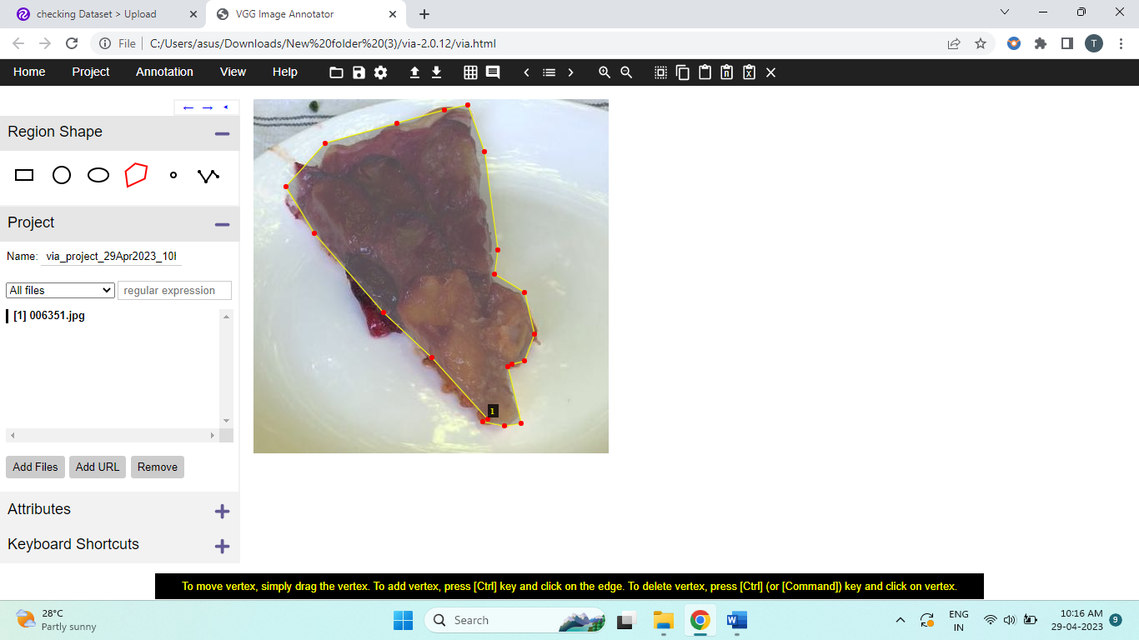

Made use of vgg annotator to build polygon mask around the subject.

Tried to implement Mask-rcnn model but was facing issues.

So I went for an alternative option which was detector 2 and as able to get relevant results using smaller sample.

So currently I’m working on it to increase the sample size and build a bigger model using detectron2

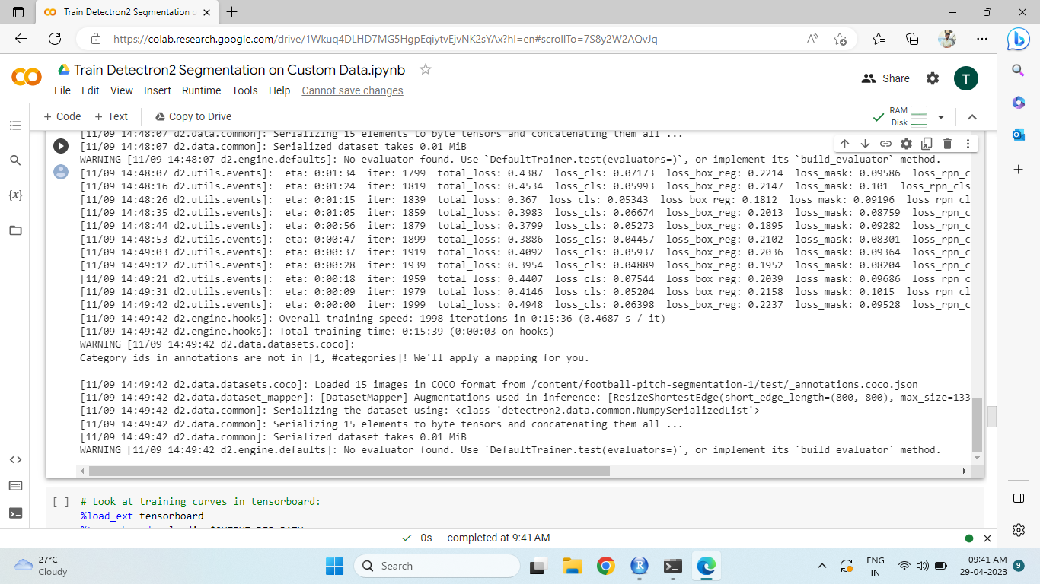

Implemented Image segmentation on a data set which I extracted from Kaggle it had a json file which had information of mask of each pic in the training model and I was able to train a model which had 459 different classes. And I trained the model using detector 2 and implemented transfer learning technique on the Mask-Rcnn R_101_FPN model and I was getting some relevant results

**Output Samples:**

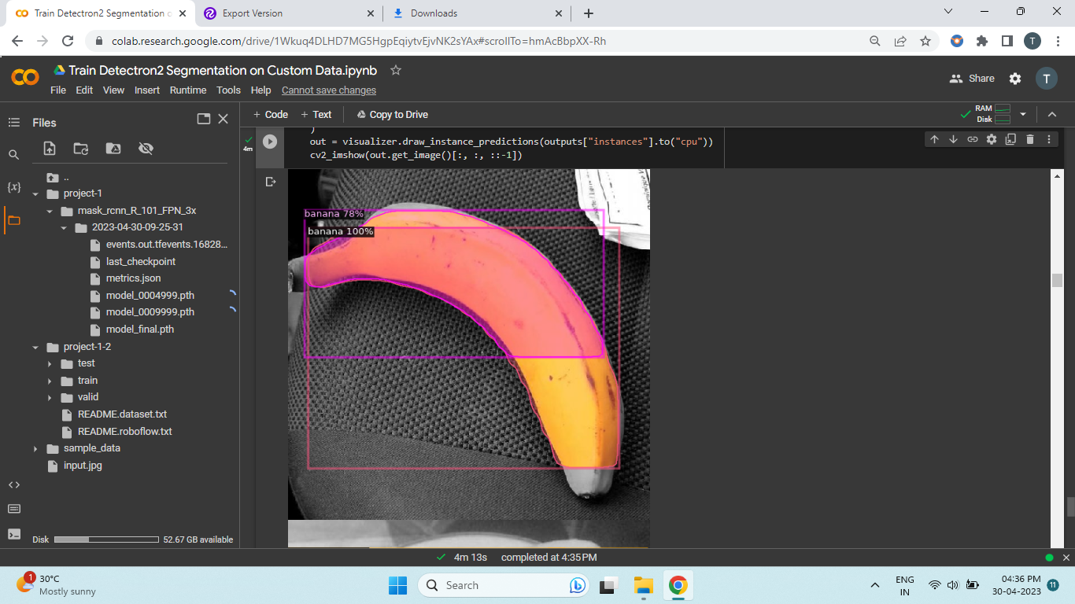 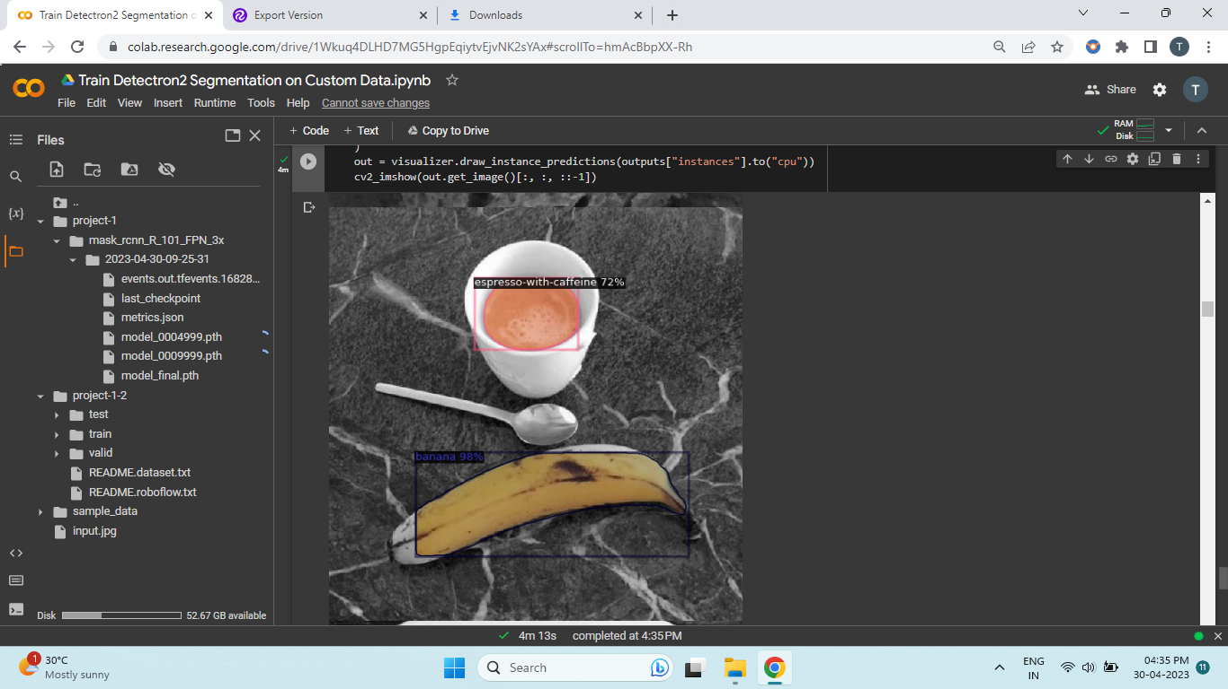 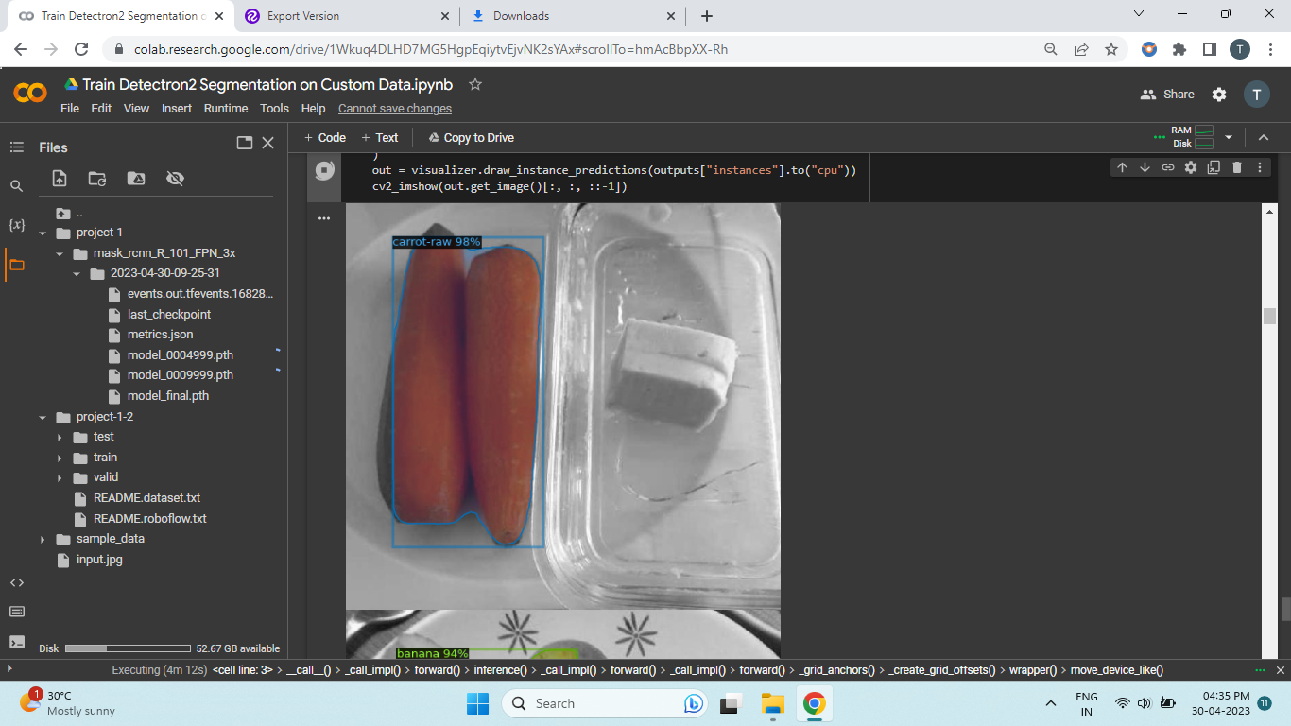 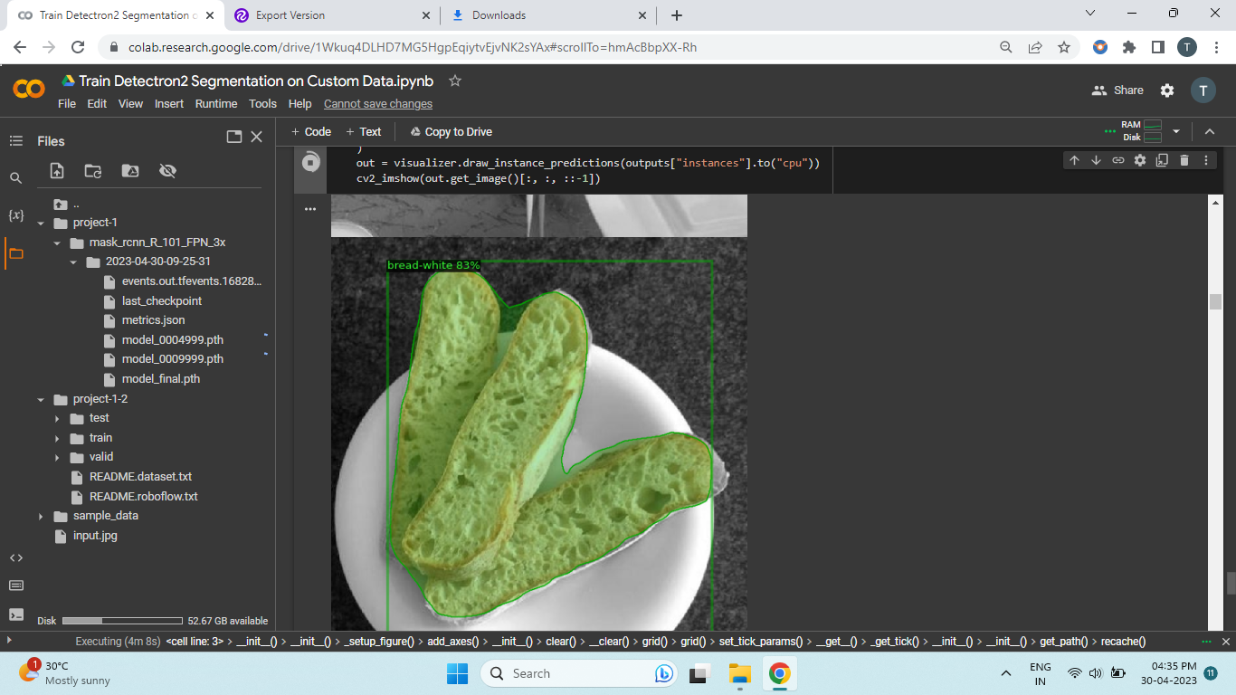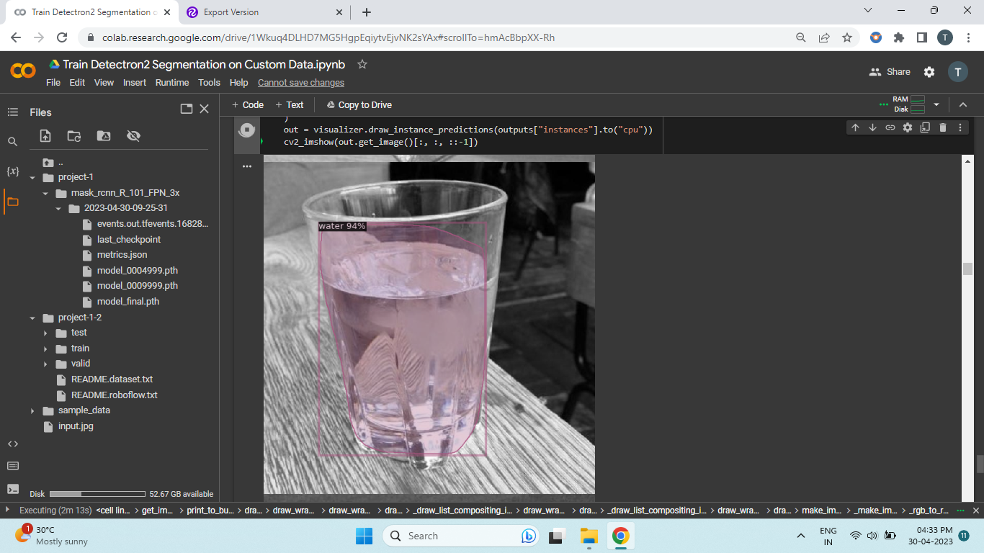 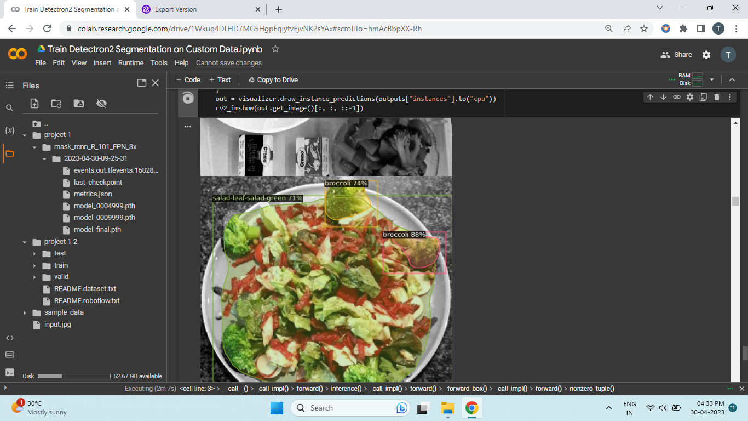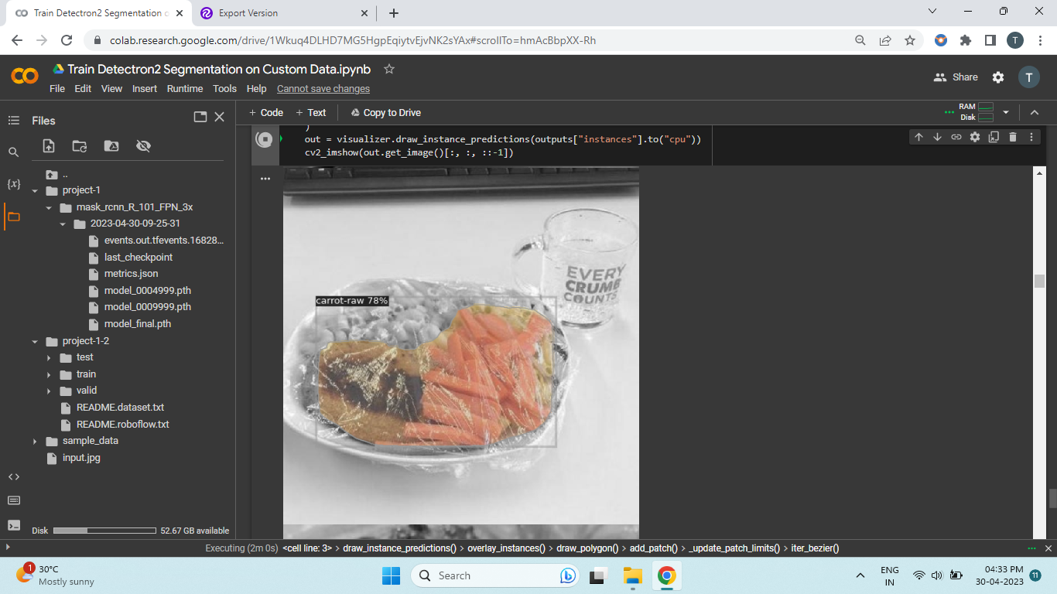 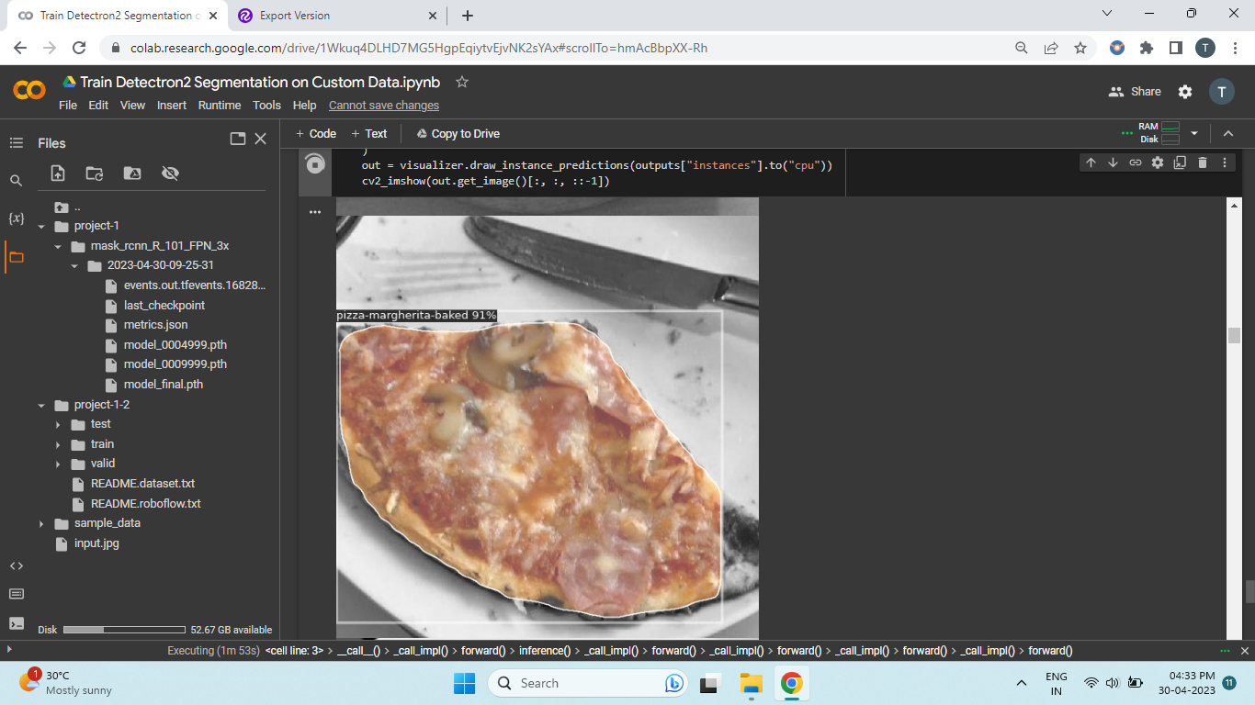 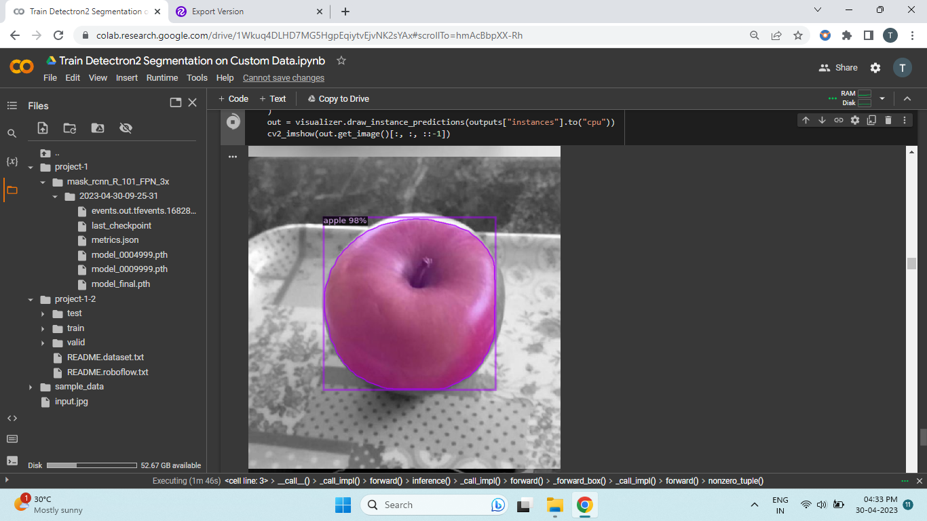 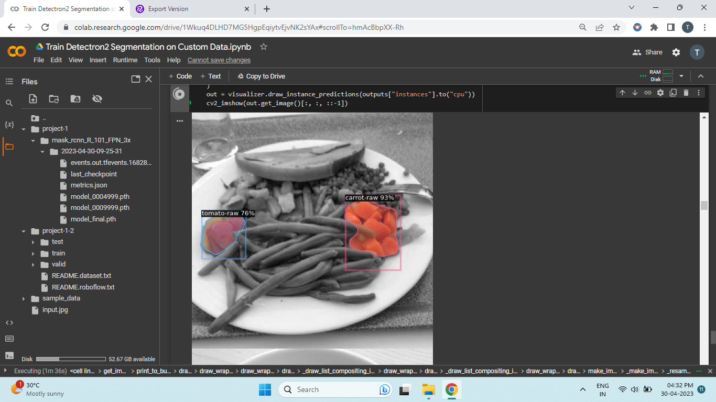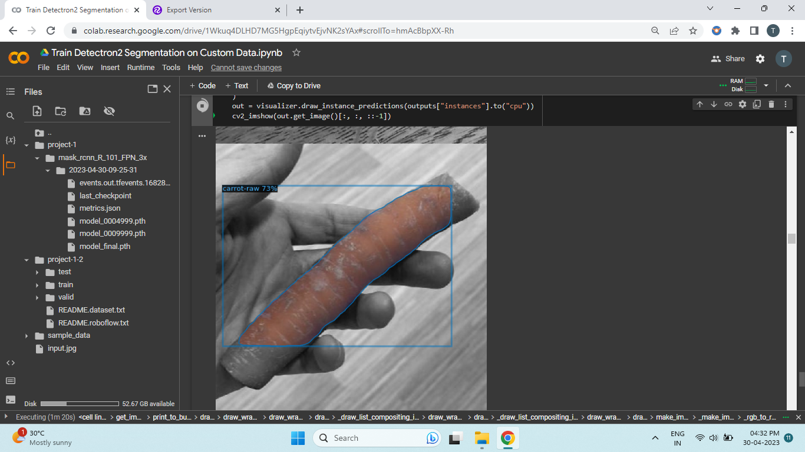 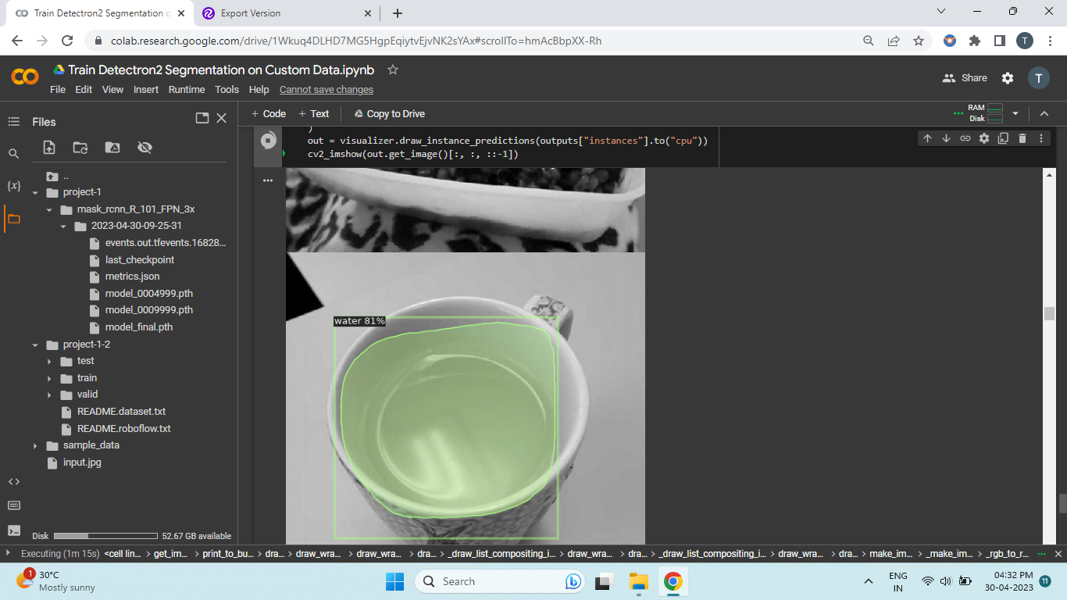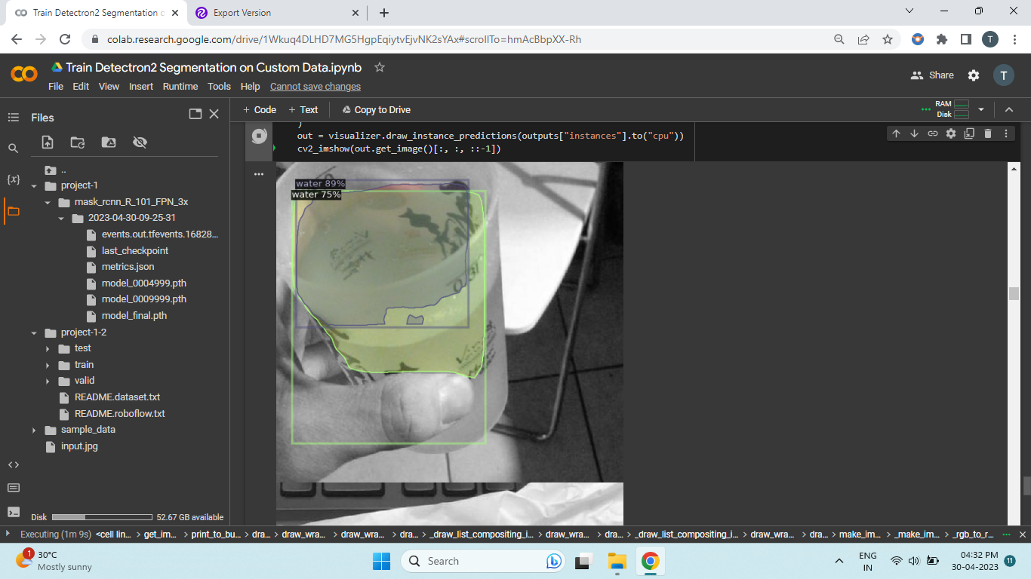 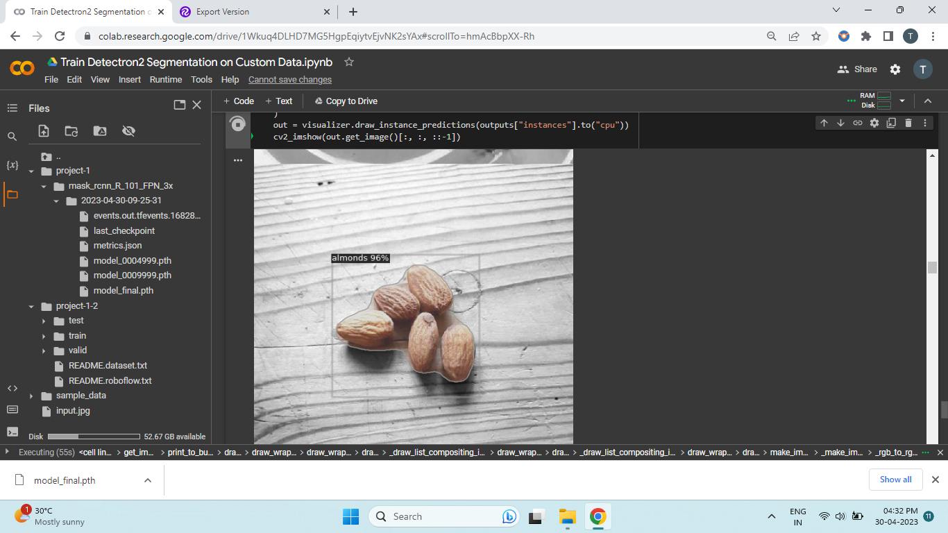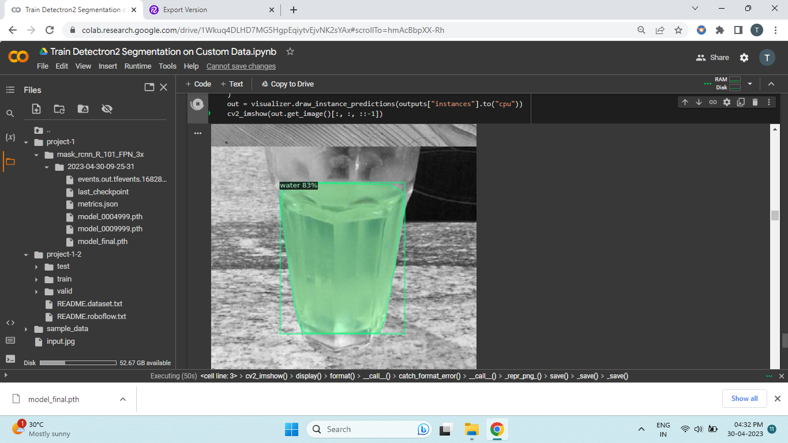 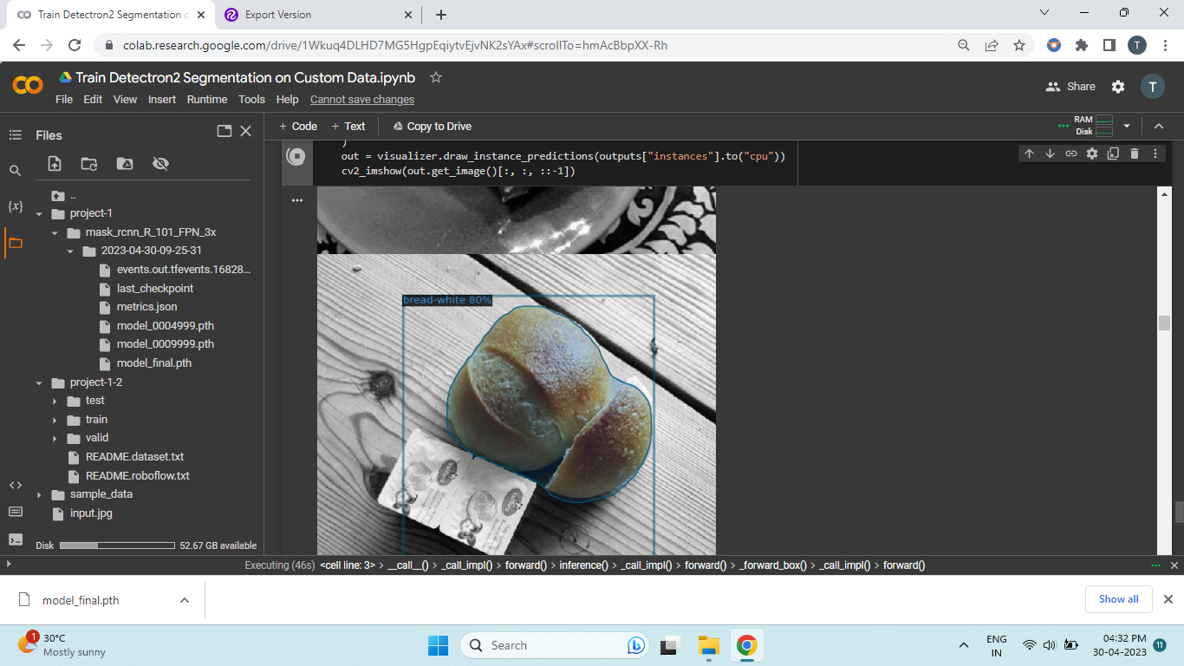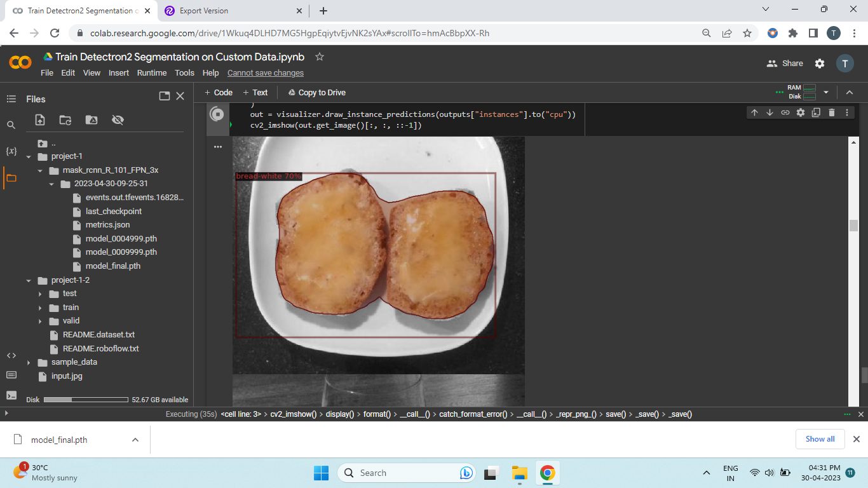 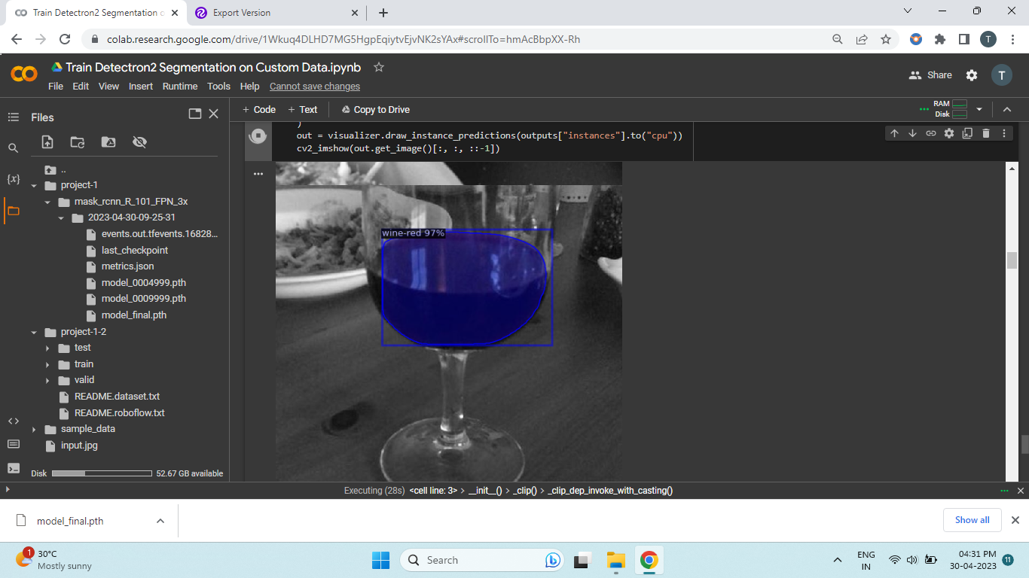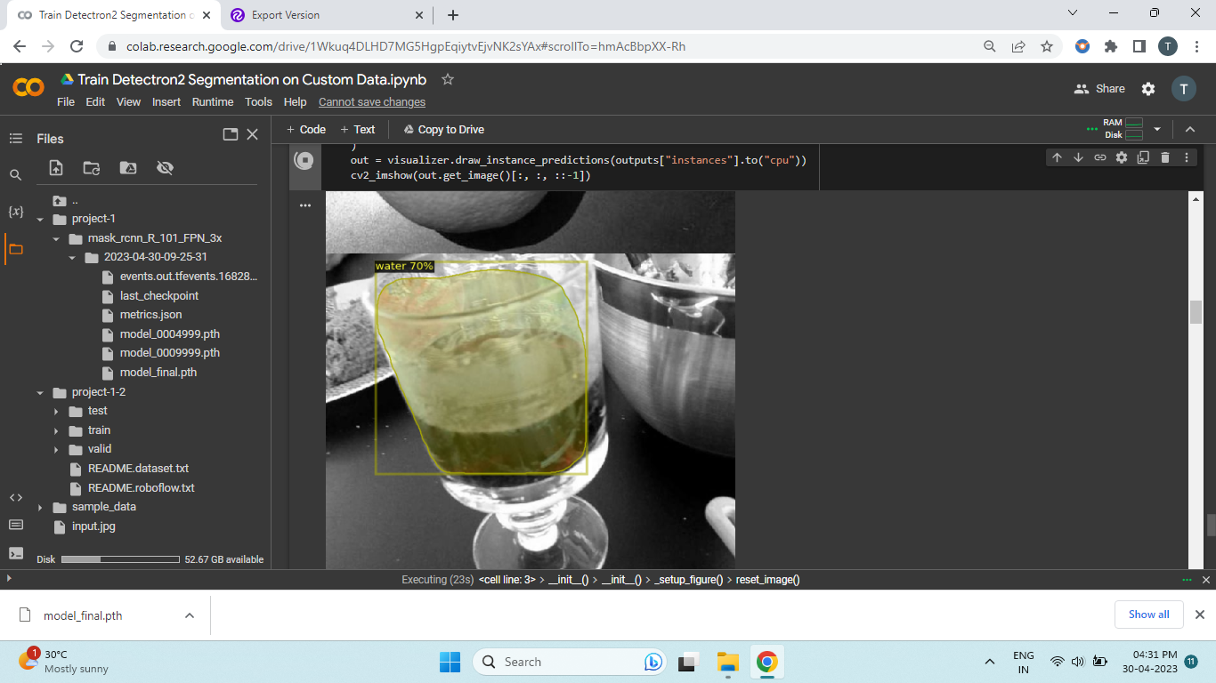 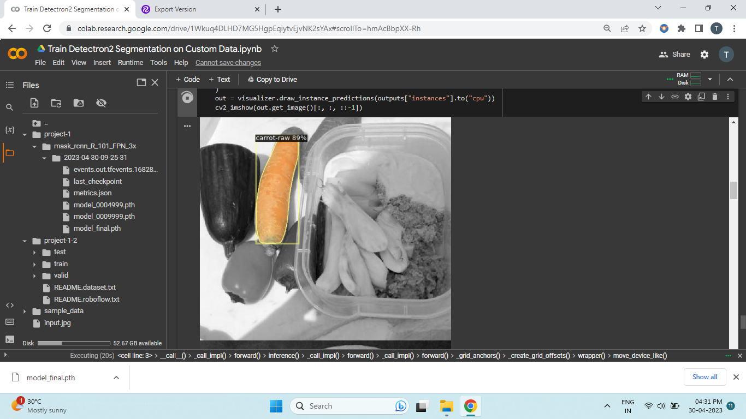

This model was created after 10000 iteration and the accuracy can be further increased by increasing the iterations but due to GPU limitations in colab I was able to generate this model

**Combined Model:**

Combined the 3 methods image classification using resnet v2 , yolo v5 image detection and detectron 2 image segmentation to create a unified model which can detect different items in the pic.

For Nutritious information I web scrapped [www.nutritionix.com](http://www.nutritionix.com) website using selenium library to automatically download nutritious information of all the trained data set and create a data frame with it. The data frame consists of calories, fat, carbohydrate, protein, saturated fat of different food items.

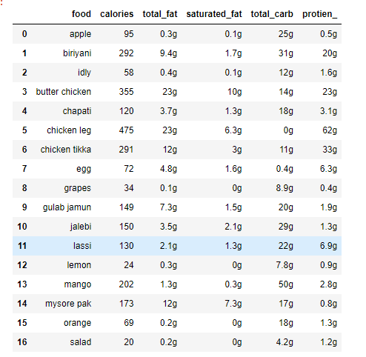

And the detected output will

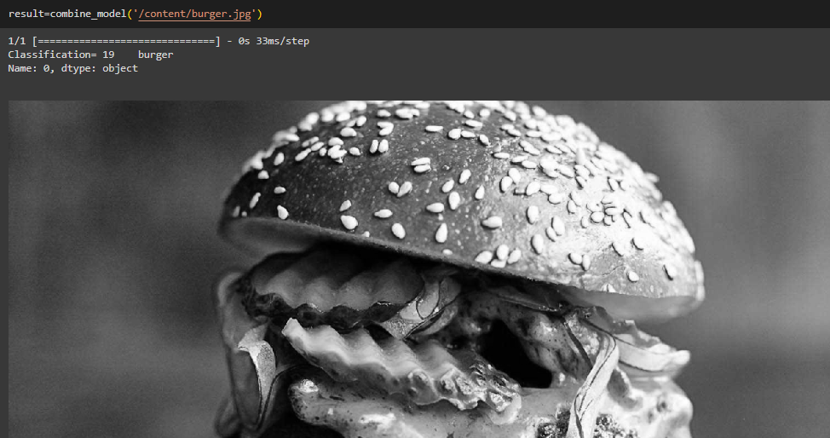

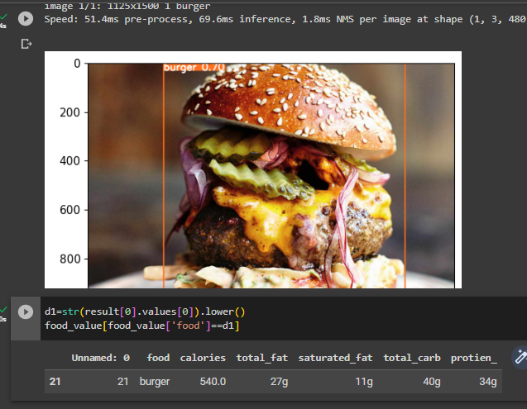

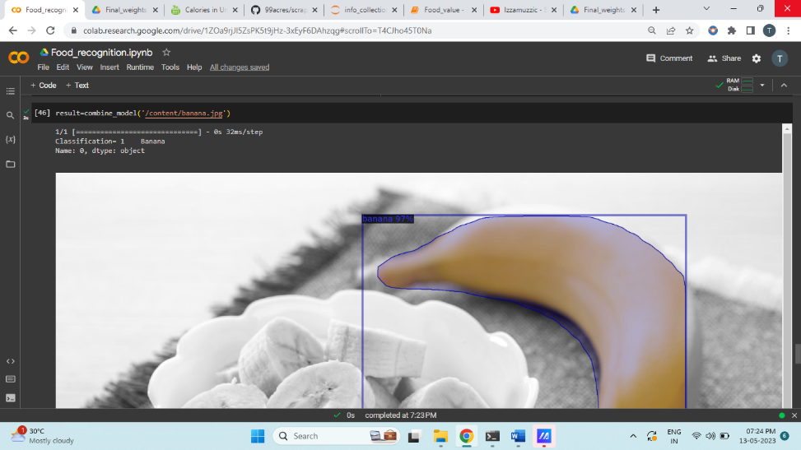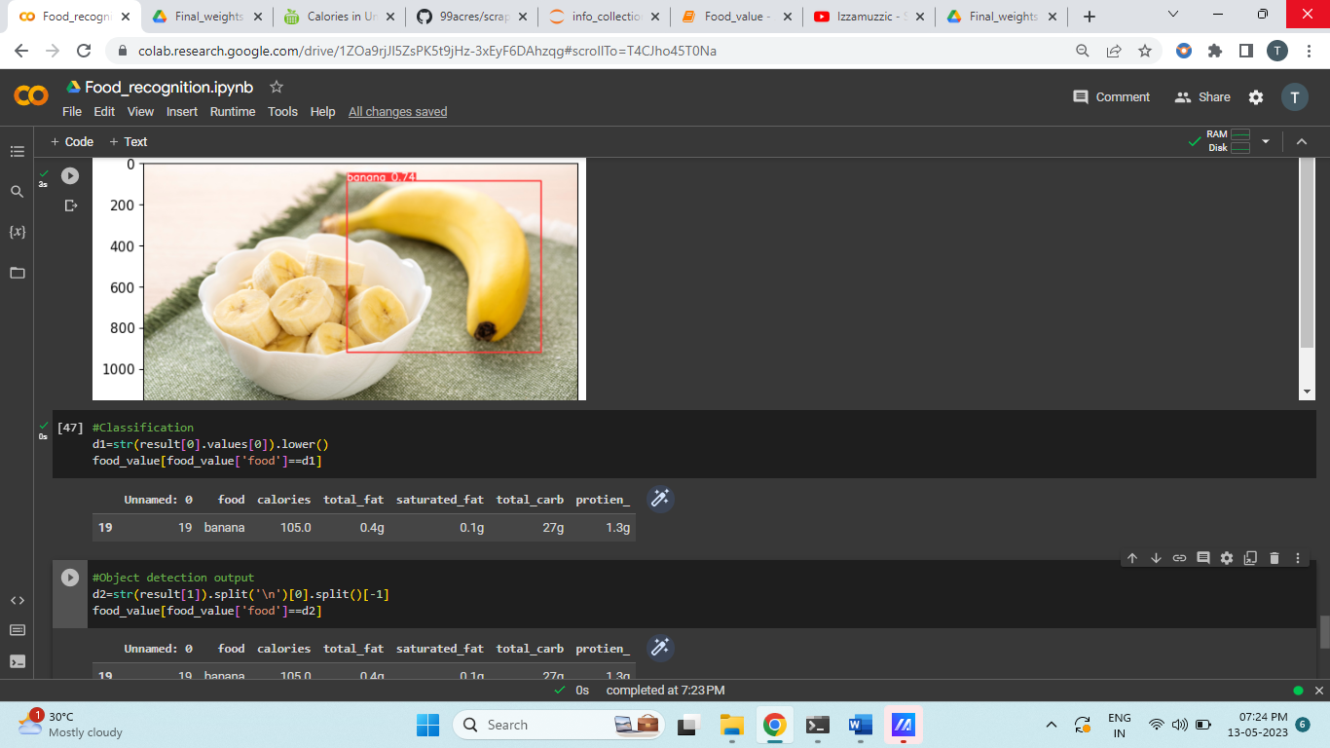

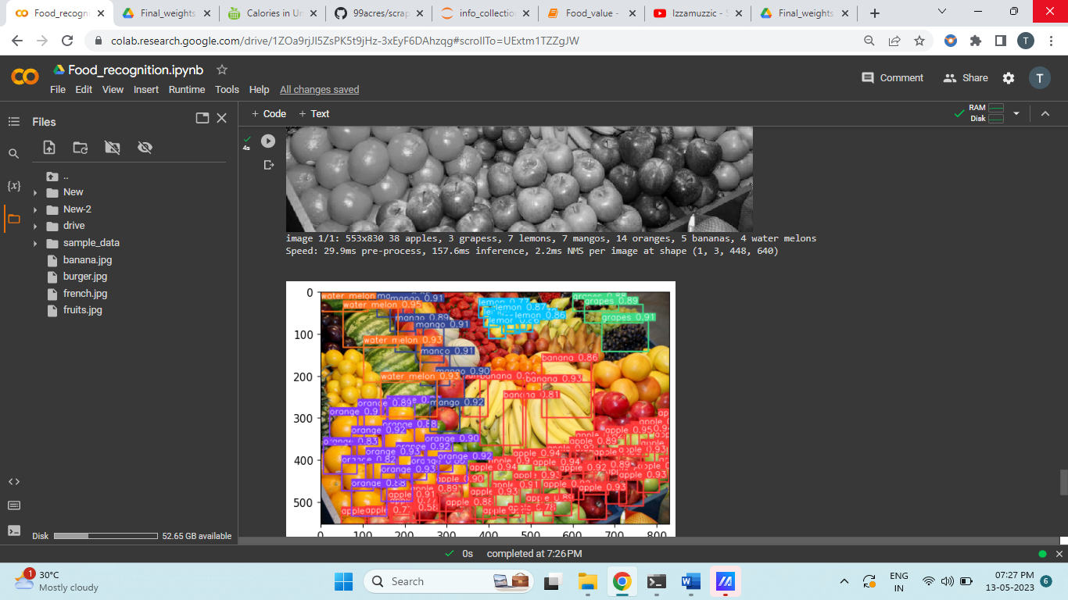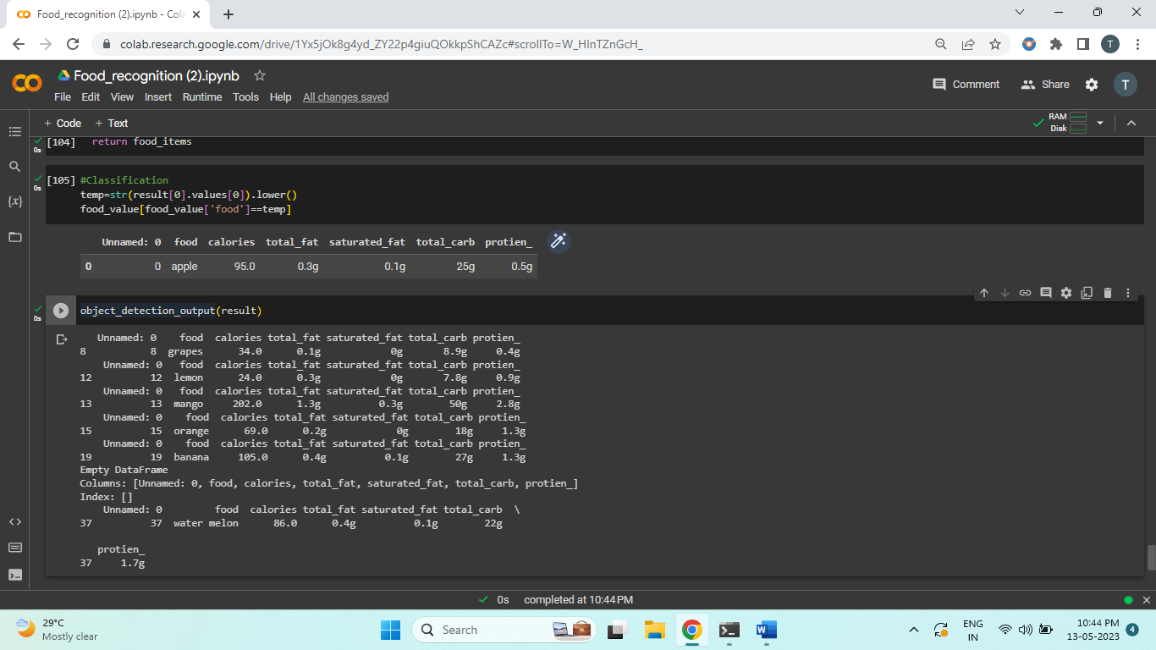

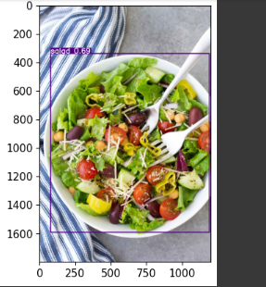

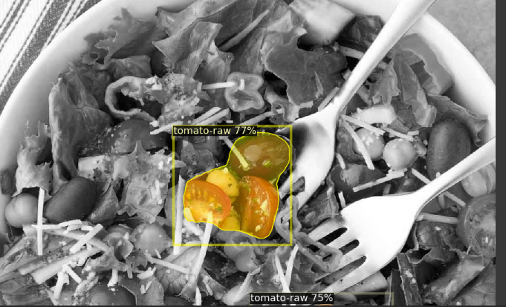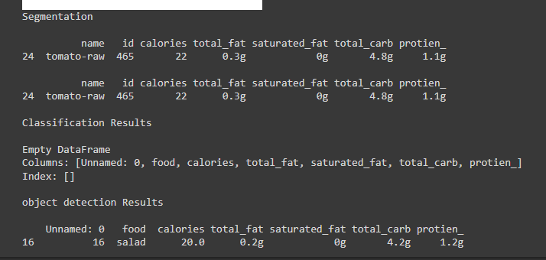

Here when the output results are passed to the above shown function it will return the nutritional information.